Answer 10
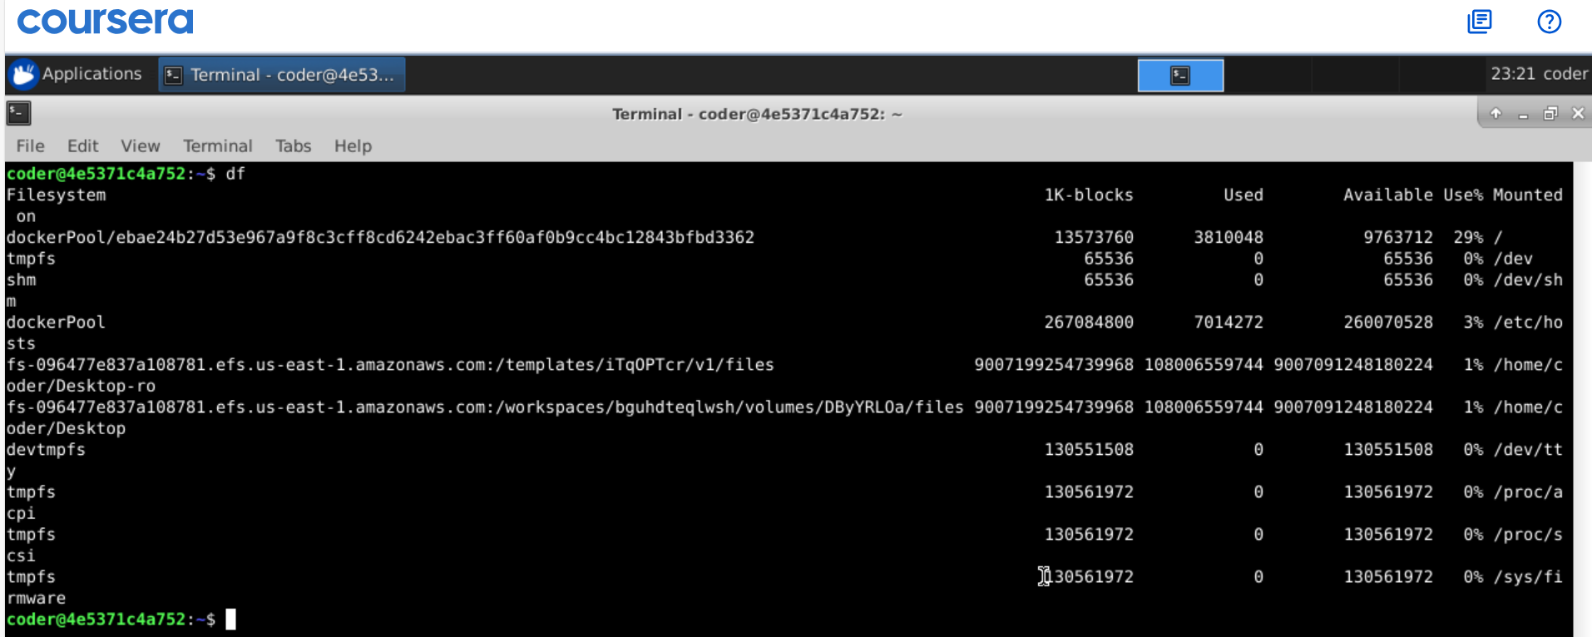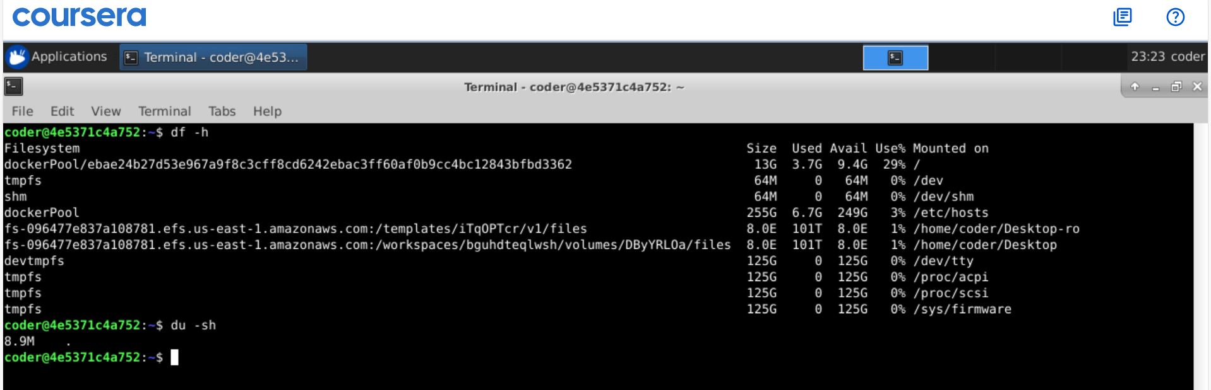
Explanation: du and df commands both are really helpful for check disk usage and free space available with filesystems. These command came with many option can be seen using --help option. In above I have used -h option for human readable size and -s option to the concise result added all sizes.

